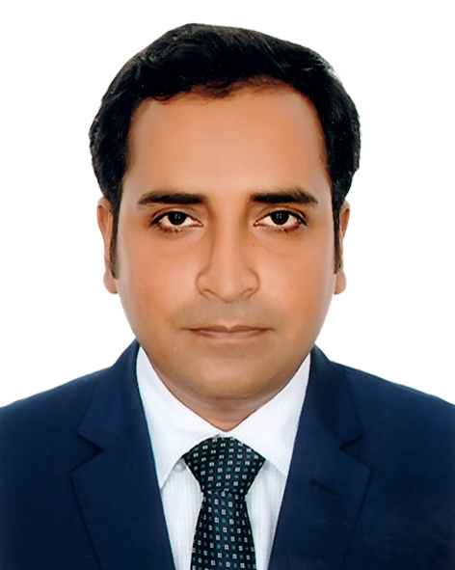

Mashrur Ahmed Menon
Mailing Address: 168/2 (3rd floor), Mulla Para, Taltola, West Kafrul, Dhaka.
Cell No.: 01712224638, Office Phone: +880 2 55045148-9
e-mail: mashrur.menon@gmail.com
_________________________________________________________________

Career Objective:
Develop career in a lively association where having opportunity to utilize and share my knowledge, experience and skill to strengthen the business capacity to attain organizational goals and objective.

Career Summary
Experience in the field of sales and marketing management.
Maintain professional relationships that meet company’s core values.
Maintain contact with all clients in the market area to ensure high levels of client satisfaction.
Successfully introduced and establish new brand in the market.

Specialties

Direct Selling and Dealer Management
Public Speaking and Presentation.
Communication and Networking.
Team Building and Management.
Business Development.
Honest and ethical tendencies.

Employment History:

Total Year of Experience: Approx. 10 Years

1. Assistant Manager (June 04, 2015 to Continuing)

HNS Automobiles Ltd.
Company Location: Police Plaza Concord, Level: 7, Plot: 2, Road: 144, Gulshan C/A, Dhaka-1212.
Department: Sales and Marketing

Business: Distributor of Hyundai Commercial Vehicles.

Duties/Responsibilities:
- Responsible for Sales and Marketing activities for Hyundai Commercial Vehicle.
- Set up and train up dealer and agent and monitoring their activities.
- Personal visit and communicate with corporate and individual clients to maintain relationship.
- Regular update database for actual & potential client’s and follow-up.
- Engage with Marketing Communications i.e. Advertising, Sales Promotions, Event Management, Public Relations & Publicity, Direct Marketing and Personal Selling etc.
- Monitor competitor’s sales and marketing strategy and discuss with management.
- Conduct market research to meet changing market and competitive conditions.
- Assist management to forecasting and preparing sales and marketing budget.
- Develop marketing & sales strategies for products as well as business.
- Organize vehicle fair, road show and demonstration.
- Collect sales payments and adjust with accounts department.
- Prepare sales & marketing report for Hyundai Motor Company and submit to Management.
- Monitor after sales service activities and make liaison with clients and service department.
2. Senior Executive (May 02, 2009 – June 03, 2015)

Uttara Motors Ltd.
Company Location: 102, Shahid Tajuddin Ahmed Sarani, Tejgaon, Dhaka.
Department: Sales and Marketing

Business: Distributor of Commercial Vehicles i.e. Isuzu, SML Isuzu, Suzuki Ravi.

Job Responsibility
- Responsible for sales and Marketing activities of commercial vehicles i.e. Isuzu, SML Isuzu, Suzuki Ravi.
- Set up and train up dealer and agent and monitor their activities.
- Personal visit and communicate with corporate and individual clients to maintain relationship
- Regular update database for actual & potential client’s and follow-up.
- Engage with Marketing Communications i.e. Advertising, Sales Promotions, Event Management, Public Relations & Publicity, Direct Marketing and Personal Selling etc.
- Monitor competitor’s sales and marketing strategy and discuss with management.
- Organize vehicle fair, road show and demonstration.
- Serve show room customers and meet their queries.
- Collect sales payments and adjust with accounts department.
- Monitor vehicle maintenance activities and make liaison with service department.
Academic Qualifications

Title : Master of Professional Marketing (MPM).
Institute : University of Dhaka.
Major : Marketing.
Class/CGPA : Appeared, Current CGPA 3.28 out of 4.00 (CGPA).
Passing Year : 2020.

Title : Master of Business Administration (MBA).
Institute : Darul Ihsan University, Dhanmondi, Dhaka.
Major : Marketing.
Class/CGPA : 3.82 out of 4.00 (CGPA).
Passing Year : 2008.

Title : Bachelor of Business Administration (BBA).
Institute : Darul Ihsan University, Dhanmondi, Dhaka.
Subject : Marketing.
Class/CGPA : 3.51 out of 4.00 (CGPA).
Passing Year : 2007.

Title : Higher Secondary Certificate (HSC).
Institute : Govt. Gouripur College, Mymensingh.
Subject : Science.
Class : 2nd
Passing Year : 2002.

Title : Secondary School Certificate (SSC).
Institute : Mukul Nekaton High School, Mymensingh.
Subject : Science.
Class : 1st
Passing Year : 2000.

Training
Training Title | Topic | Trained by | Location | Duration
Becoming Professional Sales Consultant | Importance of Sales. Attitude of Sales Consultant. Difference between professional & amateur. Corporate philosophy, vision and core values. | Hyundai Training Academy (HTA Truck & Bus) | Online | 7 days
TCO & Negotiation Events | Understanding of TCO, Use of TCO calculator, Competitive advantage with TCO analysis. Understanding of Negotiations, Negotiation scenario for Truck & Bus. | Hyundai Training Academy (HTA Truck & Bus) | Online | 7 days
Marketing & Sales Strategy | Communication and value  Creation, negotiation and sales strategy. | Hyundai Motor Company | Online | 7 Days
SAP Operating | Using SAP Software | PWC  India & Uttara Motors Ltd. | Dhaka. | 1 Months
Internship. | General Banking | Mutual Trust Bank Ltd. | Dhaka. | 3 months

Certification

Topic Covered | Institute | Duration
Microsoft Office, Graphic Design, Operating System and Internet. | Bhuiyan Computers | 6 months
Digital Marketing Conclave-2019 | MPM Club, University of Dhaka | 1 Day
Presentation & Interview | The School for Presentation & Public Speaking,  University of Dhaka | 1 Day
Effective Communication Skills & Networking | Youth School of Development | 1 Day

Personal Strength & Skill
- Self-motivated, hard-working and quick learner.
- Able to work under pressure, take responsibility and leadership role.
- Effective managing and problem-solving capacity.
- Knowledge and practice on ICT in office application.
- Language proficiency in Bengali and English.

Extra-Curricular Activities
- Engage with various social activities i.e. President of Mosque and Secretary of Eidgah field.
- Worked with Red Crescent Society for distributing relief at 1998 flood.
- Organized blood donation program at College & University.
- Played Inter School Football & Cricket tournament
- Engaged with Scouting at school & College.
Hobbies
Travelling, Tree Plantation, Playing Football, Cricket, Badminton, Chees, Internet Browsing. Reading Newspaper, Reading Case study, Reading Article’s, Reading Novels, Reading Poem, Computer Games, Fishing, Debating etc.

Personal Information
Father’s Name : Late. Muhammed Azizul Huq.
Mother’s Name : Ayesa Akther.
Date of Birth : 31 December 1985
Nationality : Bangladeshi
NID No. : 509 733 8783
Blood Group : A + Ve
Gender : Male
Spouse Name : Mowmita Talukder
Religion : Islam
Permanent Address : Village: Tenua, Post Office: Hiranpur, PS: Purbadhola, District: Netrakona.

References:
Professor Dr. Md. Mizanur Rahman  Chairman, Marketing Department  Faculty of Business Studies, University of Dhaka.  Cell: 01712139762  Phone: 9661920-73/7974, 7955  e-mail: drmizanhira@yahoo.com | Muhammad Kamal Hossain  Additional Deputy Commissioner of Police (ADC)  Deputy Police Commissioner Office, Pallabi Zone, Dhaka Metropolitan Police, Dhaka.  Cell: 01911287423, 01713398489  e-mail: kamallawdu@gmail.com

I hereby assert that the above information is true to my knowledge and the documents relevant to the information may be provided as when needed.

Thanks, and Best Regards

___________________
Mashrur Ahmed Menon.

